1.0 Scope |  |  |  |  | 2.0 Resource Required
1.1 Purpose: To ensure smooth stuffing of finished goods to deliver safe & Okay material to customers.  1.2 Area of Application: Warehouse  1.3 Responsibility: Loading Supervisor  1.4 Accountability: HOD Warehouse & Dispatch |  |  |  |  | 2.1 Man: Loading Supervisor, Forklift Driver, Nailer  2.2 Machine: Forklift / EOT Craine, nail gun,  2.3 Material: Finished Goods & Packing material, Wooden plank, plastic strap, nail
3.0 Terms and Definition |  |  |  |  | 4.0 Key Performance Requirements
3.1 SQM: Square meter  3.2 EOT: Electric overhead traveling |  |  |  |  | 4.1 Quality: Material needs to be loaded with proper checking without any damage.  - EHS: Dust Pollution & Cut Injuries.
5.0 Frequency |  |  |  |  | 6.0 Training & Communication
5.1: As per dispatch plan |  |  |  |  | 6.1 Training needs to be Given To all Loading supervisor, nail gun operator.  6.2 Visual posters are to be used for Do’s & Don’ts & communication.
7.0 Procedure
7.1 Sequence of Operation

7.1.1 Truck condition inspection.  - Truck floor – it should be uniform (zigzag free) and no holes, broken parts, no zigzag  - Top cover – No holes allowed  - Turck body – It should be even, no holes, and no broken welding joints.  - Closing door and lock – It should be in working condition and clamping should be OK.  - Identification no.- Number should be readable properly  If any of the above points fail to comply, reject the truck and ask driver to take the truck out.  Fill in the truck inspection checklist with necessary remark for all OK and rejected truck. |  |  |  |  |  | 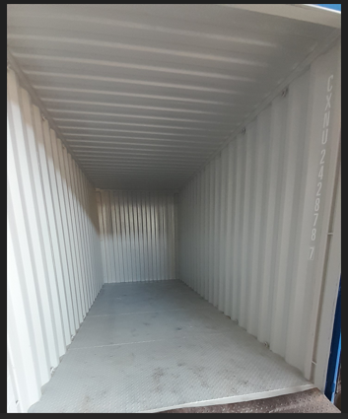
7.1.2 Truck allocation to loading platform
- Once the truck inspection is done, for inspected OK truck ask driver to take inside loading platform in reverse direction.
Note: take slowly and ensure no hitting to the side of platform.
- Once the parking is done as per marked location, apply hand break & place the wheel choker to prevent the movement of the truck
7.1.3 Prestaging of the material
- Based on the Loading advise, find the material with mentioned size & detail
- Pre-stage the material near the loading platform.
- Define the loading plan to distribute the equal load inside the container based on the pallet size and container size.
7.1.4 Loading of the material inside container.
- Scan the pallet barcode with PDT to confirm the details of the material.
- Based on the loading plan, pick the pallet with forklift and lift it up.
- Using air gun, clean the pallet and make it dust free.
- All Barcode need to scan by PDR before loading started
- Using forklift, take the pallet inside the container and place it at the end (based on loading pattern).
- Lash the boxes with container using binding strip.
- Repeat the same process for all the pallets considering the loading pattern, to maintain the load distribution uniform.
Note: Ensure the loading will be done in staircase pattern.
- After completing the loading, fix the wooden plank and nail it.

7.1.5 Finalizing of the loaded truck  - After completing the loading, fix the wooden plank on empty space and nail it to block the movement of the pallet/box.  - Each activity should be done under camera monitoring.  - Once the stabilization is complete, paste the A4 size paper with date, container number & customer as shown in the image.  - Click the picture of the image and save it the drive.  - Fumigation of the container (applicable is the pallets were made from Pine wood)  - Seal the container.  - Handover the required documents to the truck driver.  - Ask truck driver to takeout the Wheel chocker.  - Take the truck out of the platform slowly. |  |  |  |  |  | 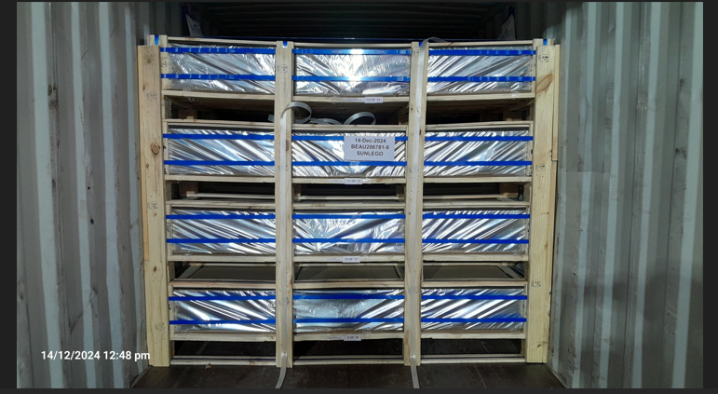  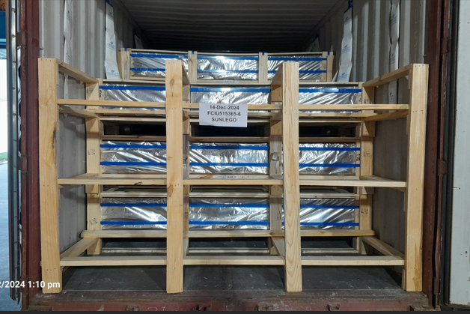
7.2 Special Process Requirements
7.2.1 Fumigation would be done in case of Pine wood box.
7.2.2 “ISPM” stamp required on wooden plank. |  |  |  |  |  | 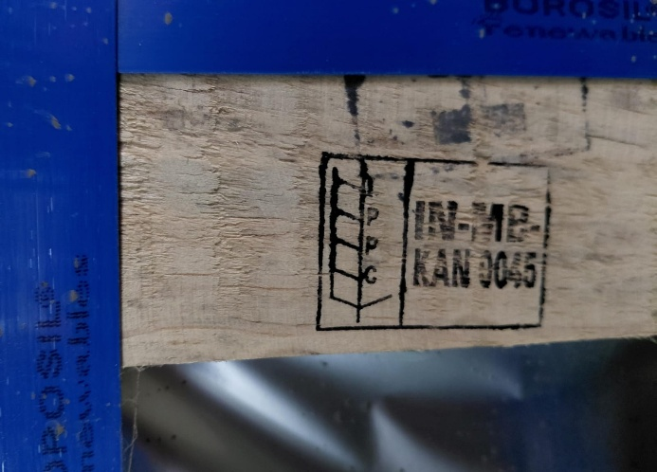
7.3 Prevention & Detection Controls
7.3.1 Floor conditions must in even with steel floor
7.3.2 Material must be with QA OK stamp.
7.4 Controls Related to EHS
7.4.1 PPE MATRIX
 |  | 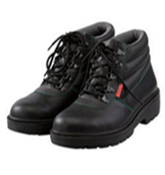 |  |  |  |  |  | 
Goggles |  | Safety Shoes |  | Hand Gloves |  |  |  | Dust Mask
7.4.2 Used nails & metal strap must be disposed of in scrape box, to avoid injury.
7.4.3 Wood dust need to keep in Bags.
8.0 EHS Compliance Obligations
8.1 NA

9.0 Possible deviation & Impacts |  |  |  |  |  |  | 10. Proposed actions
9.1 Uneven floor may cause damage in FG Goods while transit.  9.2 Broken glass in pallet my lead to break other glass too. |  |  |  |  |  |  | 10.1 Check the tuck floor & it must be in good condition.  10.2 Before loading the pallet, check for any broken glass physically.
11. Reference documented information
  - SG Finish Good Check List – WH/L4/003

12. Revision History
Revision No. | Date |  | Description of changes
00 | 12.02.2020 |  | Initial release
01 | 31.10.2025 |  | Format revised and more detailed

